Academic Qualifications:  Associate Professor;  PhD in psychology; RN (China); Psychologist(China)  Contact Information:  Institute: Zhengzhou University  Department: College of nursing  Location: No. 100, Kexuedadao, Zhengzhou city, PCR  Mobile: 8615038004037  Email: 894499618@qq.com | 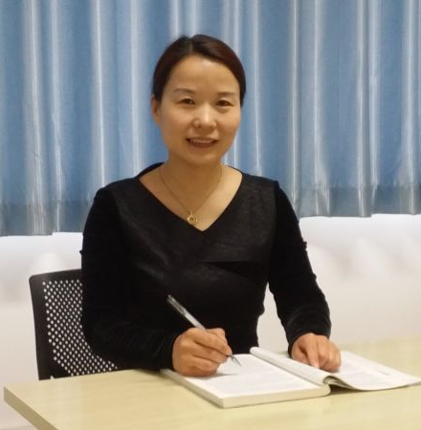
Academic Introduction of Zhang Rui-xing

Education history:
- 09.1992—07.1997: Shandong medical university, majored in advanced nursing, medical bachelor degree
- 09.2003—07.2006: Medical college of Zhengzhou university, majored in psychological biological, Medical master degree
- 09.2007—06.2011: Educational college of Zhengzhou university, majored in education, Study direction is mental hygiene, Doctor degree
Abroad study:
- 04.2016-01.2017: KU Leuven. Psychomotricity therapy in mental disorders. length of 10 months.
- 08.2006-10.2006: Nursing school of of New South Wales in Austrilia Clinical nurse education, length of 2 months.
- 08.2011: Nanyang Polytechnic in Singapore. Programme on NYP education concepts＆academic management, length of 2 weeks.

Teaching:
- Nursing Psychology
- Theory and Practice of Psychological Care
- Psychiatric Nursing
- Fundamental of Nursing
Research Interests:
- Psychological Care of Patients with Somatic Disorders
- Child and Adolescent Mental Health Improvement
- Psychological Intervention for Insomnia
- Mental Health Improvement of Older
Methodological Knowledge:
- Survey design
- Qualitative research
- Randomized controlled trials
Research program:
- Relations between the perpetuating factors, physiological and biochemical indicators of the chronic insomnia, Basic and updated technology research program of Henan Province.
- Research of the theory and the practice about the role of the “consulting expectation” in the mental health education. Philosophy and social sciences planning project of Henan province.
- Neurophysiological and biochemical mechanism of the paradoxical insomnia. International cooperation projects of Zhengzhou science and technology bureau.
- The humanistic care model of psychiatric department in comprehensive hospital. Social development projects of Zhengzhou science and technology bureau.
- Comparison between the mental health improvement of the adolescents in China and England. International cooperation projects of Zhengzhou science and technology bureau.
- Research of the positive psychological traits of university students. Humanities and social science project of education bureau of Henan province.
- Practice of the service of the medical students to community and rural academic based on the school assignment. Key projects of education science and the 12th five-year plan project.
- Curriculum reform of the mental health nursing based on the principle of “graduality and the fusion”. Health vocational education teaching reform project.
- Teaching model reform of the nurse training based on the clinic nursing pathway. Health vocational education teaching reform project.
- Research of children's mental health of the prisoners. International cooperation projects of Zhengzhou city technology bureau.
- Development and use of the software system of the College students' mental health education. Educational science planning project of education bureau of Henan province.
Publications of Articles:
- Effects of Chinese traditional feeding habits on the eating disorders and the psychological analysis (first author). Eating Behaviors. 2015, 17 (2015) 83–85
- Machiavellianism in Chinese adolescents: Links to internalizing and externalizing problems(first author). Personality and Individual Differences, 2016, 89, 19-23.
- Analysis of the intervention effect of paradoxical intention therapy in patients with community chronic insomnia(first author). Modern preventive medicine. 2016, 43(24):4474-4476.
- Mediating effect of positive coping style between Machiavellianism and loneliness in adolescents (first author). Chinese journal of behavioral medicine and brain science. 2016, 25(11):1015-1017.
- Comparison between the effect of nonhypnotic imaginative suggestion with positive somatic thoughts guidance and the CBT on the senile PSPD patients(corresponding author). Chinese journal of gerontology. 2016, 36(20):5110-5112.
- Effect of nonhypnotic imaginative suggestion with positive somatic thoughts guidance in the PSPD patients (corresponding author). Chinese journal of pain medicine. 2016, 22(2):152-154.
- Alexithymia characteristic in elderly in patients with somatoform disorders (first author). Chinese journal of gerontology. 2015, 35(8)，4660-4661.
- Research progress of mindfulness therapy and enlightenment to clinical nursing (corresponding author). Chinese journal of practical nursing, 2015, 31(3):231-234.
- Relationship between the expectation and the effect in clinical psychological counseling and the advices for the psychological work (first author). Medicine and philosophy. 2015, 36（2B）72-74.
- Investigation and analysis of the psychological characteristic of stress coping of the patients suffering chronic insomnia (first author). Medicine and philosophy. 2015, 35（8B）88-91.
- Comparative study of the psychological characteristics between the paradoxical insomnia and idiopathic insomnia (first author). Modern preventive medicine. 2014，41(15)：2773-2775.
- investigation and analysis of the psychological characteristics of patients suffering from Somatoform Disorders (first author). Medicine and philosophy. 2014, 35（2B）77-79
- Study of the psychological mechanism and coping style of the depression episode sufferers (first author). Chinese journal of behavioral medicine and brain science. 2013, 22(11):992-994.
- Investigation and analysis of the stress coping characteristics of patients suffering PSPD (first author). Chinese journal of pain medicine. 2013, 09：515-518.

Publications of Book:
- Medical psychology (chief editor). Tongji university press. 2015. ISBN 978-7-5608-5865-4
- Mental health care (chief editor). Zhengzhou university press. 2013. ISBN 978-7-5645-1369-6
- Psychiatric nursing (chief editor). Henan science and technology press. 2012. ISBN 978-7-5349-5643-0
- Mental health education in university students (assistant chief editor). Zhengzhou university press. 2013. ISBN 978-7-5645-1491-4
- Nursing management (editor). Tongji university press. 2008. ISBN 987-7-5608-3683-6/R.232
- Feeling good (translator). Henan science and technology press. 2008. ISBN 978-5349-3598-6
- Fundamental of nursing (editor). Zhengzhou university press. 2003. ISBN 7-81048-729-9/R.555

